

**Faculty of engineering - Shoubra**

**Benha University**

**Research Article / Research Project / Literature Review**

in fulfillment of the requirements of

|  |  |
| --- | --- |
| **Department** | Engineering Mathematics and Physics |
| **Division** |  |
| **Academic Year** | 2019-2020 Preparatory |
| **Course name** | Computer |
| **Course code** | ECE001 |

**Title: -**

Building a website about Programming Languages

By:

|  |  |  |  |
| --- | --- | --- | --- |
|  | Name | Edu mail | B.N |
| 1 | Kerolos Saed Gaber | Kerolus195687@feng.bu.edu.eg | 615 |

**Approved by:**

|  |  |
| --- | --- |
| Examiners committee | Signature |
|  |  |
|  |  |
|  |  |
|  |  |
|  |  |

**Research objectives**

-I have chosen a programming language topic to clarify some points:

1- To know what is the c programming language .

2-To know what is the different between users in the past and now.

3-Parts of the created website pages and their corresponding source codes.

4-Links to the Github repository.

**Abstract**

-C language Tutorial with programming method for beginners and professionals can help you understand the tutorial in C language easily. Our C tutorial discusses single subject with the programs

-Dennis Ritchie introduces the C Language to build machine applications that communicate directly with hardware devices like drivers, kernels, etc.

-C language is considered as the mother language of all the modern programming languages because most of the compilers, JVMs, Kernels, etc. are written in C language, and most of the programming languages follow C syntax, for example, C++, Java, C#, etc.

**Table of contents**

Divide your research into sections or subjects, mention each section first page at this table

|  |  |
| --- | --- |
| **Subject / section** | **Page** |
| Research objectives | 2 |
| Abstract | 3 |
| Introduction | 5 |
| Literature Review | 6 |
| links | 12 |
|  |  |

**Introduction**

- .C is a language of the procedural programming. In the year 1972 it was first developed by Dennis Ritchie. It was primarily developed for writing an operating system as a programming language for the system. C language's main features include low-level memory access, a basic collection of keywords and clean style, making C language ideal for device programming such as an operating system

- Many later languages directly or indirectly borrowed syntax / features from C language. Like Java syntax, PHP , JavaScript, and many other languages are basically C language based. C++ is almost a superset of the language C.

- Development of a C program

We can formally assess the structure of a C program after the discussion above. By structure, any program is meant to be writable only in this structure. Writing a C program will lead to a compilation error in any other structure.

## - Some Facts About C Programming Language

* In 1988, the American National Standards Institute (ANSI) had formalized the C language.
* C was invented to write UNIX operating system.
* C is a successor of 'Basic Combined Programming Language' (BCPL) called B language.
* Linux OS, PHP, and MySQL are written in C.
* C has been written in assembly language.

**Literature Review**

- What's programming on C?

C is an extremely popular, simple, and flexible programming language for general use. It is machine-independent, standardized programming language that is commonly used in many different applications.

-C was the universal language for writing everything from operating systems ( Windows and many others) to complex programs such as the Oracle database, Git, Python interpreter and more.

- It is said that the programming language for a god is 'C.' One could say, C is a programming base. If you know 'C,' you can easily grasp other programming language knowledge that uses the concept of 'C'

Having a background in computer memory mechanisms is essential, as it is an important aspect when dealing with the programming language of C.

- Story of the C language 'ALGOL' is the basis or father of the programming languages. It was first published in 1960. In European countries 'ALGOL' was used to a large degree. 'ALGOL' introduced the technology world to the idea of formal programming. In 1967, a new computer programming language named 'BCPL' was announced which stands for Basic Combined Program Language

screenshot:

1)The main page and its code:

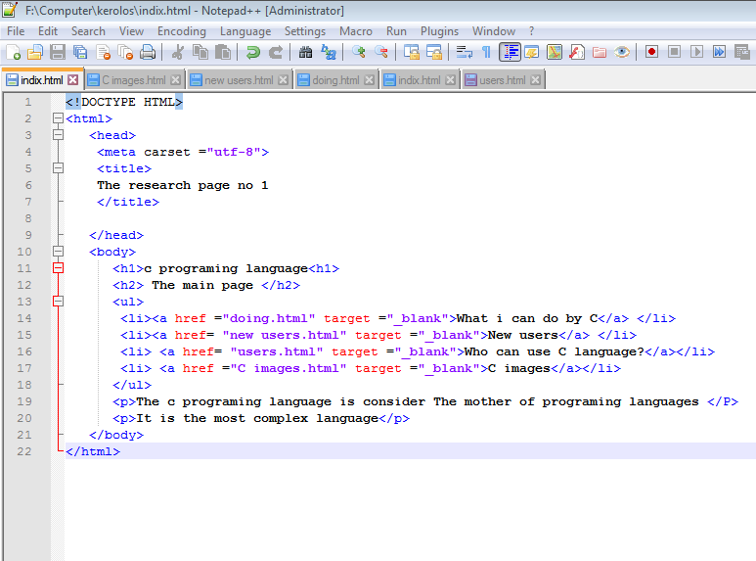

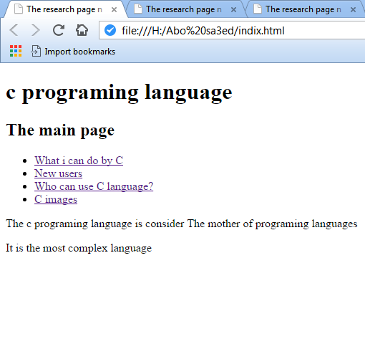

2)This is the c image and its code as follow:

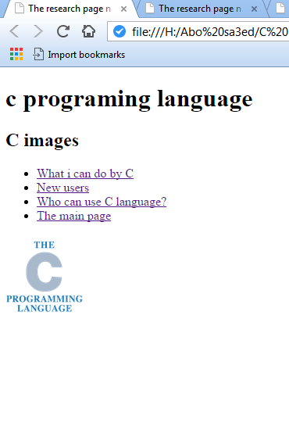

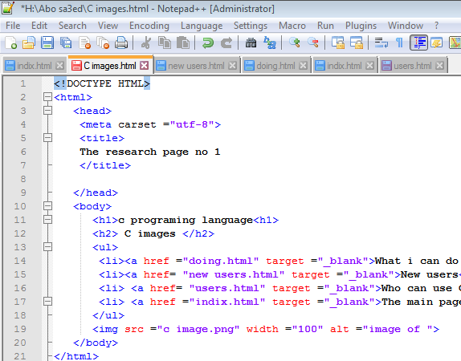

3)Some usage of c programming language as follow:

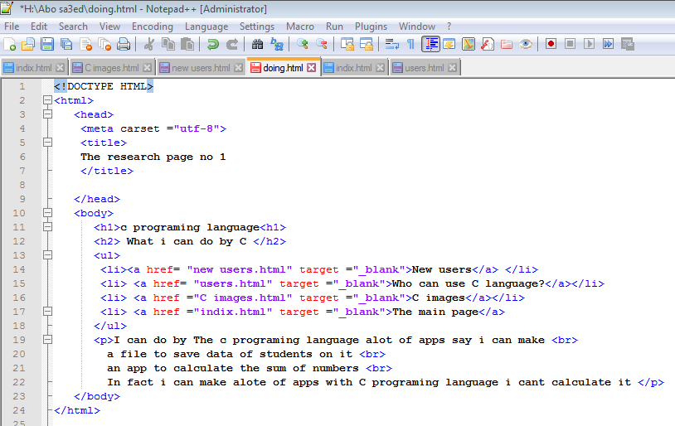

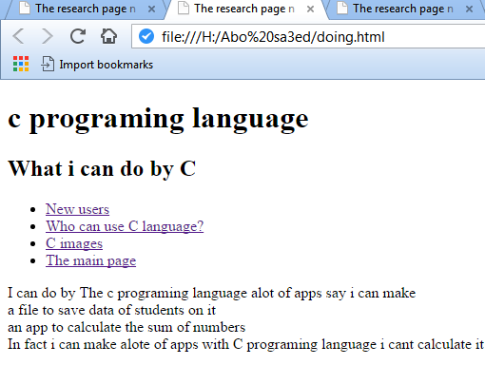

4)the different between now and in the past of usage of c programming as follow:

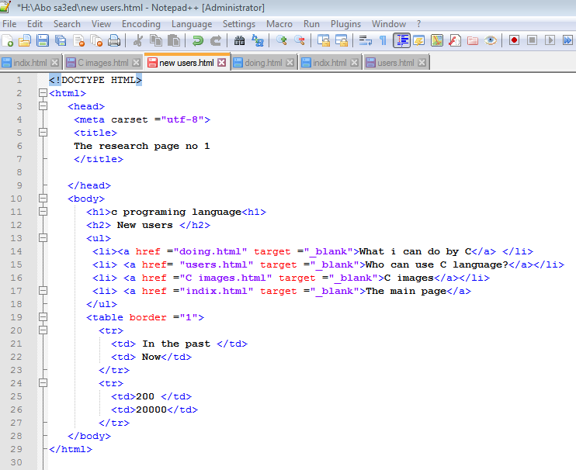

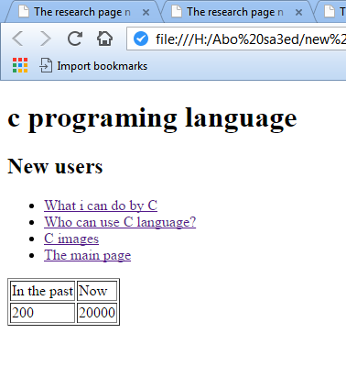

5)The following screenshots to clarify who can use the c programming language ?:

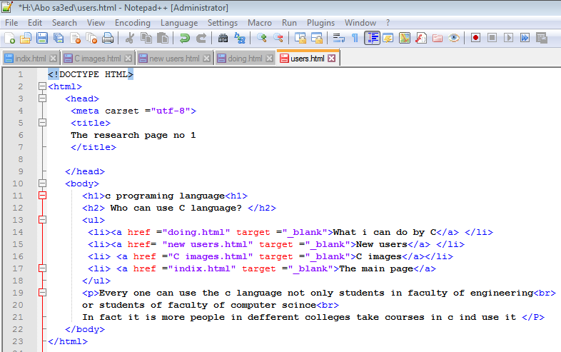

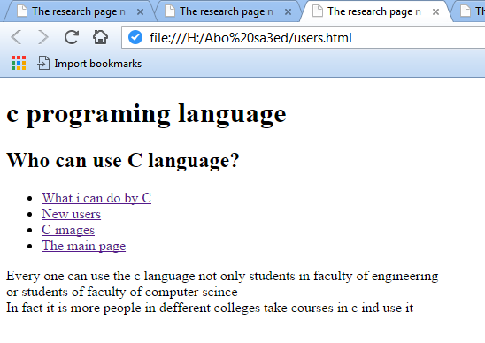

**links**

Github link :

**Layout and formatting**

**(Guide, don’t include this page in your research)**

Use this template

**Paper:** A4

**Margins:** 2.5 cm all from top and bottom

**1.**9 cm from left and right

**Line spacing:** 1.5

**Font:** Time New Roman

**Font size:** 14 (Except headings)

**No of pages:**Between 5 and 10 pages (Not including cover)